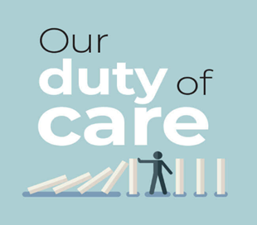

**Briefing Document for members of ODOC**

**Summary of Key Arguments**

**1.Suicide is not a true choice when there is not access to good care.**

Patients cannot make a true choice about assisted dying when they do not have access to care when they need it, day or night. This includes general and specialist palliative care, social care and psychological support. A wish to die may be transient and treatable with explanation, counselling and medication alongside good symptom control.

**2. It disadvantages the most vulnerable in society**

Terminally ill and disabled individuals may begin to devalue themselves because they feel a burden. Legislation on assisted suicide, designed to empower, may erode the choices of the most vulnerable. Pressure is subtle and may be exerted by families and clinicians. Patients feel a burden in all sorts of unspoken ways. The Oregon Health Authority annual reports shows about a half of those choosing assisted suicide mentioned the fear of being a burden on family, friends or caregivers as a factor in their decision.

**3. It contravenes inherent human dignity**

One of the foundations of societies is the prohibition of killing other people. This is due to a high view of the worth of human life. The UN Universal Declaration of Human Rights affirms, ‘the inherent dignity and the equal and inalienable rights of all members of the human family.’ A state decision to sanction the taking an individual’s life is a significant action. The primary danger of assisted suicide is that individuals are devalued by society. This may be because they are ill, disabled or confused.

**4. It should never be part of medical care.**

Trust is the foundation of the clinician-patient relationship. The fact that a doctor or nurse might instigate death changes the relationship when a patient is ill and seeking care. There must be clarity that a doctor will never intentionally cause harm to a patient.

**5. It may be extended to those groups that we seek to protect**

Canada introduced assisted dying for the terminally ill in 2016. This has since been extended to those who are disabled but not dying in 2021 and planned for those who are mentally ill in 2027. It is impossible to provide effective safeguards when they are challenged by strong equality legislation. *The current law is the safeguard.*

*Our duty of care* is a group of healthcare professionals across the UK who oppose the intentional killing of patients by assisted suicide or euthanasia. We are a campaign that is financed and administered by the Care Not Killing alliance. Further information can be accessed at http://ourdutyofcare.org.uk